1a. Using the molecular formula C6H10, draw the structure of one molecule that is conjugated and one molecule that is not conjugated.

b. Draw a representation of the bonding in each compound and use it to explain why one molecule is conjugated and one is not.

c. This is a porphyrin ring structure. It is a component of both heme (the oxygen carrier in blood) and chlorophyll. Is this compound conjugated? What effect do you think this will have on the light absorbed by the ring structure?

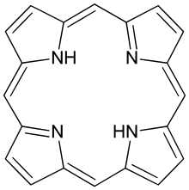

2. When 2,3-dimethyl-1,3-cyclohexadiene is treated with HBr more than one product is formed.



a. Draw out the mechanism for this reaction, including any intermediates, and use it to predict the structures of the possible products.

b. Draw an energy diagram for the reaction including reactants intermediates and products.

c. Use the reaction energy diagram to help you explain which product you predict would be formed preferentially at low temperature.

d. Use the reaction energy diagram to help you explain which product you predict would be formed preferentially at high temperature.

3. Complete the following reactions



4. Devise a synthesis of this compound using starting materials with 2 carbons or fewer and appropriate reagents

